 

MET BKC IIT CDAC-ACTS

NASHIK

Documentation On

**“Online Barbershop Management System”**

PG-DAC 2021

*Submitted By:*

**Group No: 07**

**Names & roll numbers**

**Yash Walke (2154)**

**Jugal Chavan (2029)**

**Vaibhav Deokar (2035)**

**Mr. Akash Thakur Mr. Akshay Khsirsagar**

**Centre Coordinator Project Guide**

# Table of Contents

1. **Introduction ..................................................................................................................... 1**

Document Purpose ....................................................................................................... 2

Problem Statement ....................................................................................................... 2

Product Scope .............................................................................................................. 2

Aim & Objectives ........................................................................................................ 2

1. **Overall Description ......................................................................................................... 3**

Product Perspective...................................................................................................... 3

Benefits of Society Management System ..................................................................... 3

User and Characteristics ............................................................................................... 3

Operating Environment ................................................................................................ 3

Design and Implementation Constraints ....................................................................... 3

1. **Requirements Specification ............................................................................................ 4**

External Interface Requirements .................................................................................. 4

3.3 Non-Functional Requirements ................................................................................... 12

1. **System Diagram ............................................................................................................ 11**

Activity Diagram ....................................................................................................... 11

Data Flow Diagram .................................................................................................... 13

Class Diagram ........................................................................................................... 15

Use Case Diagram ..................................................................................................... 16

ER Diagram ............................................................................................................... 16

1. **Table Structure ............................................................................................................. 17**

Flat owners ................................................................................................................ 17

Notices ...................................................................................................................... 17

Complaints ................................................................................................................ 17

Visitors ...................................................................................................................... 18

Bill ............................................................................................................................ 18

Workers ..................................................................................................................... 18

1. **Conclusion ..................................................................................................................... 19**

Future Scope .............................................................................................................. 19

1. **References ...................................................................................................................... 20**

# List of Figures

Figure 1 Admin Activity Diagram ................................................................................... 11

Figure 2 Flat Owner Activity Diagram ............................................................................. 12

Figure 3 Watchman Activity Diagram.............................................................................. 12

Figure 4 Level 0 Data Flow Diagram ............................................................................... 13

Figure 5 Level 1 Data Flow Diagram ............................................................................... 13

Figure 6 Level 2 Data Flow Diagram for Admin .............................................................. 14

Figure 7 Level 2 Data Flow Diagram for Flat Owner ....................................................... 14

Figure 8 Level 2 Data Flow Diagram for Watchman ........................................................ 15

Figure 9 Class Diagram ................................................................................................... 15

Figure 10 Use Case Diagram ........................................................................................... 16

Figure 11 ER Diagram ..................................................................................................... 16

# Introduction

The need for hairdressing, grooming, facials, and related services will not decline as long as people live on this earth. In fact, in this age of fashion and corporate culture, people are more interested in grooming themselves than ever before. So, the beauty salons and hairdressing businesses are always on the rise. Having that in mind, for the people in need of websites for such businesses. During this pandemic situation the zero contact policy is much more needed, there is no automated system for doing all the things, so we present you Online Barber Shop Management System. Easy to use Barber Shop software to manage online scheduling, appointment booking and much more!

## Document Purpose

The Online Barber shop for saloon shop web appliction is inteneded to provide complete solutions for vendors as well as customers through a single get away using the internet. The E-Barber Shop System allows customer to register and login. After that customer can select the location after selecting the location he can select shop he prefer. He can select the services that he wants from that shop. He can also select multiple services after that he can select the time slot as he prefer and book the appointment. Our E-Barber Shop System streamlines scheduling so that you can make appointments seamless and super organized for everyone.

This E-Barber Shop Management System is developed to provide the following services:

Customer looking for new Barber Shop:

Let customers find Barber Shops in desired area and book appointments easily through popular discovery platforms like reserved with Google, Facebook and Instagram.

Shopkeepers looking for new online platform:

Shopkeeper will get a new platform and will get notified whenever a new appointment is booked, confirmed or cancelled

Monthly Bill generation:

This system’s key functionality is that it helps in generating the monthly bill of the society conveniently.

## Problem Statement

Existing system for a society is based on our traditional way keeping records and details on paper and registers. Access of these details and papers are not granted to common member in absence of the authority. It is hard to manage all the society system with pen and paper. It gets really hard to maintain the records and then keep track of past records. Hence this system is proposed to overcome the flaws of the existing system and giving power to the admin of the society so that he/she will be able to manage the society easily.

## Product Scope

This project traverses a lot of areas ranging from business concept to computing field, and required to perform several researches to be able to achieve the project objectives. The area covers include:

* Housing industry: This includes study on how the daily Society work actually is being done, process involved and opportunity that exist for improvement.
* J2EE Technology used for the development of the application.
* General customers as well as the society’s staff will be able to use the system effectively.
* Web-platform means that the system will be available for access 24/7 except when there is a temporary server issue which is expected to be minimal.

## Aims & Objectives

Specific goals are: -

* To produce a web-based system that allow the admin to add flat owners and provide functionalities to its role.
* To ease flat owners by providing different functionalities to it.
* To ease watchman to help him in his work to add and track visitors efficiently.

# Overall Description

**Product Perspective:**

2.1.1 Existing system function:

Existing system for a society is based on our traditional way keeping records and details on paper and registers. Access of these details and papers are not granted to common member in absence of the authority. For voting for various designations (secretary, treasurer, chairman, etc) in society members need to be present on site for voting. Due to some unavoidable reasons some members cannot cast vote. Proposed system has a facility for voting online which will provide anytime anywhere access. Booking a hall for celebration in a society was tedious work as details were on paper and were only accessible only to the authority which may create confusion when two or more people want to celebrate in same hall. We studied Housing Society Management System. This software system generates bill automatically and manually. It creates bill of all members at single click. In this system bills can be generated as per multiple of months i.e. monthly, quarterly half yearly etc. due day of bills can be assigned. Housing Society Management System does not allow user to cast vote or manage nominees and does not have a provision for hall allocation.

• **III. PROPOSED SYSTEM**

Product functionality:

Society Management System provides the features for admin, flat owner and watchman. It includes several functionalities describes as below:

*Flat Owner Management:*

It provides facility to add, update, delete and view the flat owners who are purchasing a particular flat in the society. We can view their details and also update it if that particular flat is sold to any new owner.

*Generating Notice:*

The admin can generate a common notice which can be viewed by all the other flat owners in their ‘View Notices’ functionality when they login in, int the system.  *Generating Maintenance Bill:*

Administrator can generate the monthly maintenance bill on the basis of the monthly water and electricity bill and the salary of the workers who are working in the society.

*Maintenance Manager:*

The project helps the administrator to generate monthly bill of the society based on various bills and salaries of workers working in the society and to be paid y society members.

## Benefits of Society Management System

* This online society management solution is fully functional and flexible.
* It is very easy to use.
* This online society management system helps in back office administration by streamlining and standardizing the procedures.
* It saves a lot of time, money and labour.
* Eco-friendly: The monitoring of the society management and the overall business becomes easy and includes the least of paper work.
* The application acts as an office that is open 24/7.
* It increases the efficiency of the management at offering quality services to the customers. • It provides custom features development and support with the application.

**Users and Characteristics:**

Admin:

* Admin can login to the system.
* View the list of all Flat Owners in the society.
* Add new Flat Owner.
* Delete Flat Owner.
* Update Flat Owner.
* View Complaints of flat owners.
* Circulate notice among all the flat owners.
* Add workers in the society.
* View workers working in the society.

Flat Owners:

* Flat Owner can login to the system.
* View his/her details.
* View notices.
* Generate complaints.
* View visitors who visited his/her flat.
* Update their personal credentials. • View monthly generated bill.

**Operating Environment:**

Server Side:

**Processor:** Intel® Xeon® processor 3500 series

**HDD:** Minimum 500GB Disk Space

**RAM:** Minimum 2GB

**OS:** Windows 8.1, Linux 6

**Database:** Oracle 11g Client Side (minimum requirement):

**Processor:** Intel Dual Core

**HDD:** Minimum 80GB Disk Space

**RAM:** Minimum 1GB

**OS:** Windows 7, Linux

**Design and Implementation Constraints:**

* The application will use Ajax, JavaScript, jQuery and css as main web technologies.
* HTTP and FTP protocols are used as communication protocols. FTP is used to upload the web application in live domain and the client can access it via HTTP protocol.
* Several types of validations make this web application a secured one and SQL Injections can also be prevented.
* Since Society Management system is a web-based application, internet connection must be established.
* The Society Management System will be used on PCs and will function via internet or intranet in any web browser.

# Specific Requirement

**External Interface Requirements:**

User Interfaces:

* All the users will see the same page when they enter in this website. This page asks the users a username and a password.
* After being authenticated by correct username and password, user will be redirect to their corresponding profile where they can do various activities.
* The user interface will be simple and consistence, using terminology commonly understood by intended users of the system. The system will have simple interface, consistence with standard interface, to eliminate need for user training of infrequent users.

Hardware Interfaces:

* No extra hardware interfaces are needed.
* The system will use the standard hardware and data communication resources.
* This includes, but not limited to, general network connection at the server/hosting site, network server and network management tools.

Application Interfaces:

**OS:** Windows 7, Linux **Web Browser:**

The system is a web-based application; clients need a modern web browser such as Mozilla Firebox, Internet Explorer, Opera, and Chrome. The computer must have an Internet connection in order to be able to access the system.

Communications Interfaces:

* This system uses communication resources which includes but not limited to, HTTP protocol for communication with the web browser and web server and TCP/IP network protocol with HTTP protocol.
* This application will communicate with the database that holds all the booking information. Users can contact with server side through HTTP protocol by means of a function that is called HTTP Service. This function allows the application to use the data retrieved by server to fulfil the request fired by the user.

# System Design

## Activity Diagram

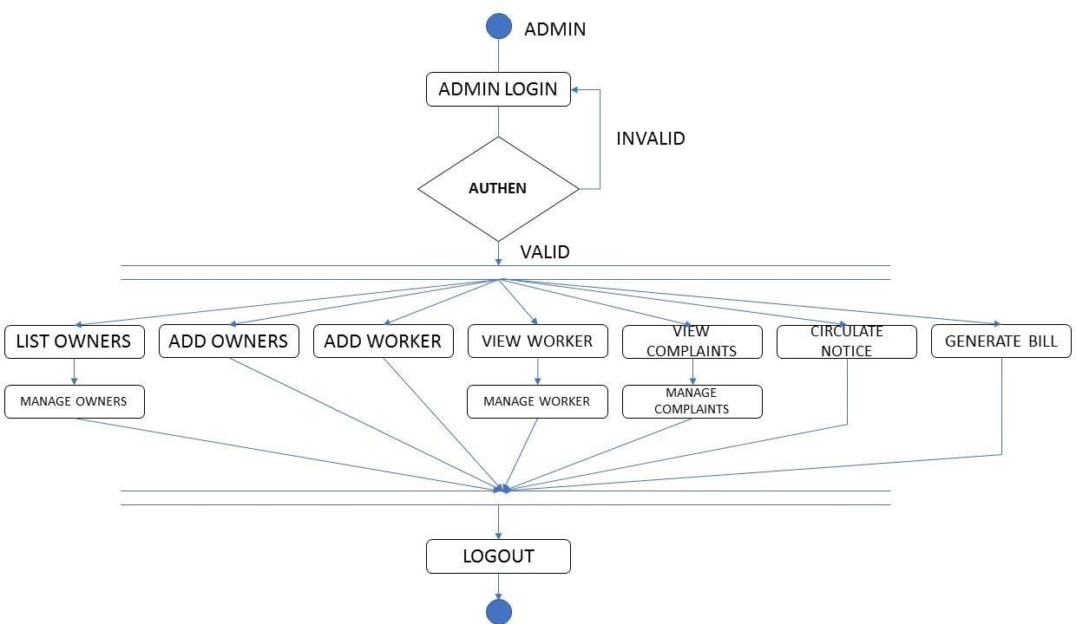

**Figure 1: Admin Activity Diagram**

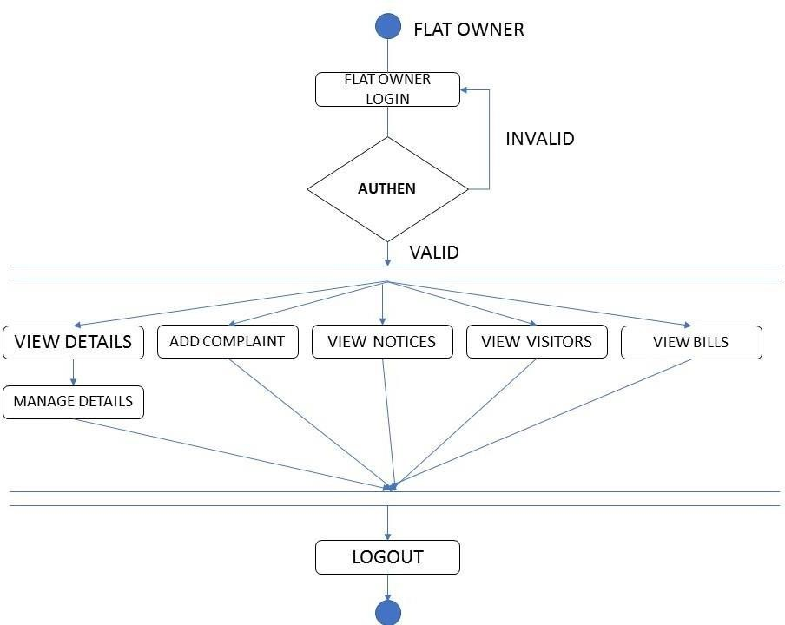

**Figure 2: Flat Owner Activity Diagram**

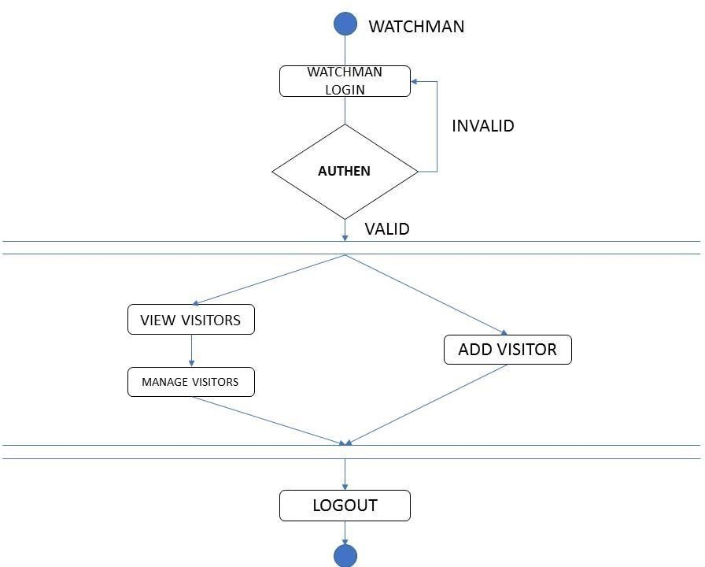

**Figure 3: Watchman Activity Diagram**

## Data Flow Diagram

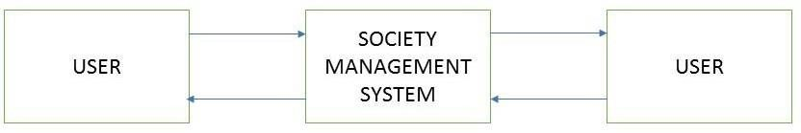

**Figure 4: Level 0 Data Flow Diagram**

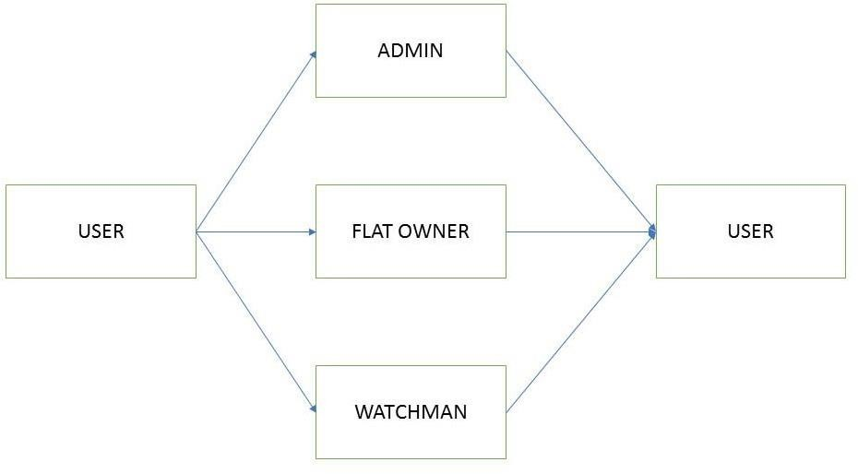

**Figure 5: Level 1 Data Flow Diagram**

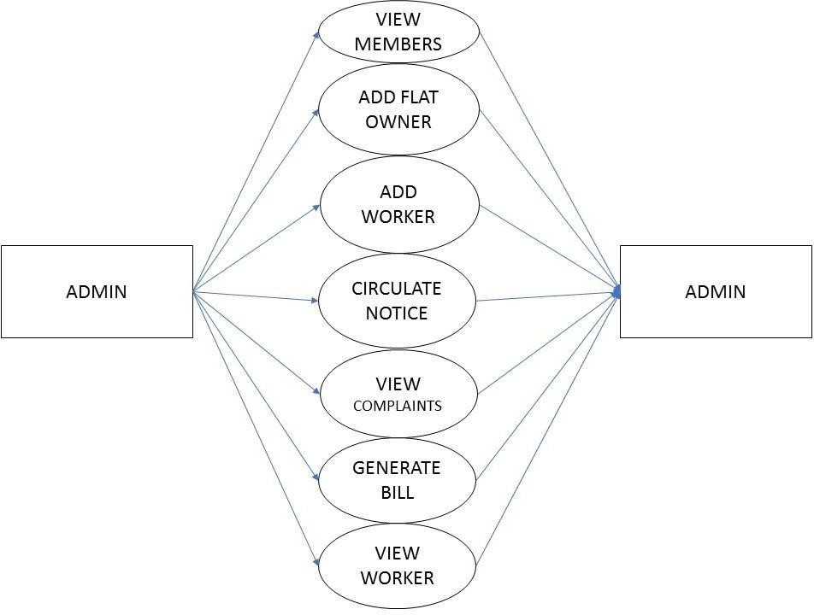

**Figure 6: Level 2 Data Flow Diagram for Admin**

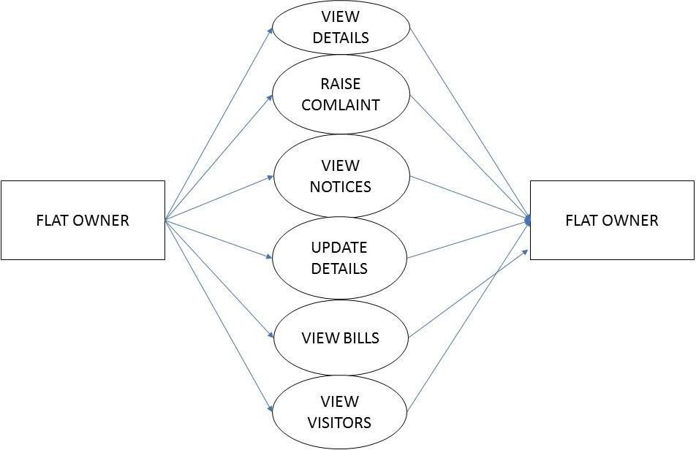

**Figure 7: Level 2 Data Flow Diagram for Flat owner**

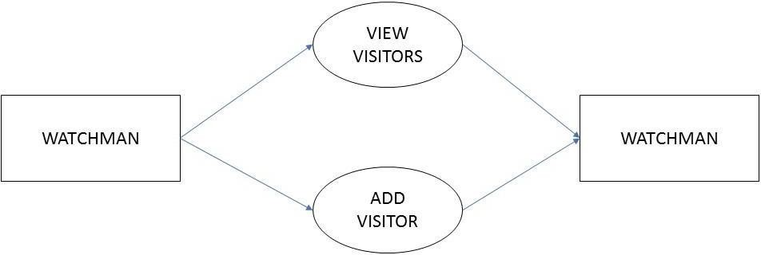

**Figure 8: Level 2 Data Flow Diagram for Watchman**

## Class Diagram

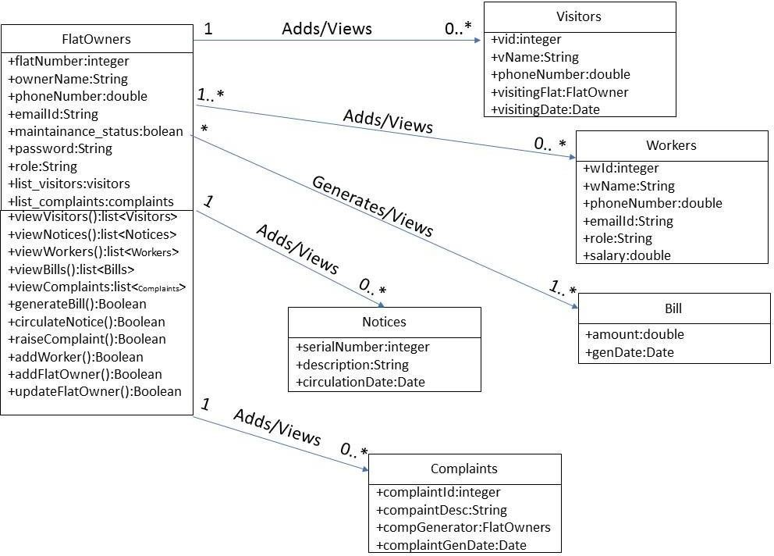

**Figure 9: Class Diagram**

## Use Case Diagram

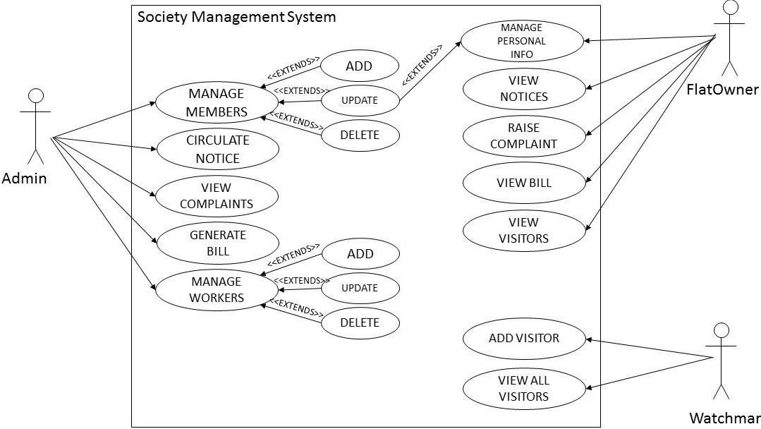

**Figure 10: Use Case Diagram**

## ER Diagram

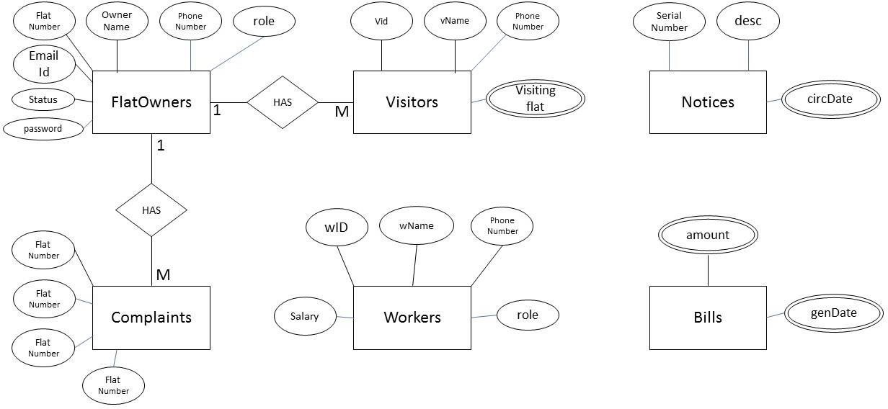

**Figure 11: ER Diagram**

# Table Structure

**Flat owners:**

|  |  |  |  |  |  |
| --- | --- | --- | --- | --- | --- |
| Field | Type | Null | Key | Default | Extra |
| f_flatnumber | number(11) | NO | PRI | NULL | Auto_increment |
| f_ownername | varchar2(30) | NO |  | NULL |  |
| f_email | varchar2(30) | NO | UNI | NULL |  |
| f_password | varchar2(30) | NO |  | NULL |  |
| f_phonenumber | number(10) | NO |  | NULL |  |
| f_role | varchar2(10) | NO |  | NULL |  |

**Notices:**

|  |  |  |  |  |  |
| --- | --- | --- | --- | --- | --- |
| Field | Type | Null | Key | Default | Extra |
| n_id | number(11) | NO | PRI | NULL | Auto_increment |
| n_description | varchar2(100) | YES |  | NULL |  |
| n_gendate | Date | NO | UNI | NULL |  |

**Complaints:**

|  |  |  |  |  |  |
| --- | --- | --- | --- | --- | --- |
| Field | Type | Null | Key | Default | Extra |
| c_id | number(11) | NO | PRI | NULL | Auto_increment |
| c_description | varchar2(100) | YES |  | NULL |  |
| c_gendate | Date | NO | UNI | NULL |  |
| c_generator | number(10) | NO | FKEY | NULL |  |

**Visitors:**

|  |  |  |  |  |  |
| --- | --- | --- | --- | --- | --- |
| Field | Type | Null | Key | Default | Extra |
| v_id | number(11) | NO | PRI | NULL | Auto_increment |
| v_name | varchar2(20) | NO |  | NULL |  |
| v_phonenumber | varchar2(30) | NO | UNI | NULL |  |
| v_visitingflat | number(10) | NO | FKEY | NULL |  |

**5.4 Bill:**

|  |  |  |  |  |  |
| --- | --- | --- | --- | --- | --- |
| Field | Type | Null | Key | Default | Extra |
| b_amount | number(11) | NO | PRI | NULL |  |
| b_gendate | Date | NO |  | NULL |  |

**5.4 Workers:**

|  |  |  |  |  |  |
| --- | --- | --- | --- | --- | --- |
| Field | Type | Null | Key | Default | Extra |
| w_id | int(11) | NO | PRI | NULL | Auto_increment |
| w_name | varchar2(20) | NO |  | NULL |  |
| w_phonenumber | varchar2(30) | NO | UNI | NULL |  |
| w_role | varchar2(10) | NO |  | NULL |  |
| w_salary | number(6) | NO |  | NULL |  |

# Conclusion

Society management system puts forth the actual working of a society. Administration, management, payment calculation, worker management, visitor management, etc. similar to a society are the key features of our project. User can access services and functionalities from the society anywhere and anytime for their own comfort.

# Future Scope

This project can be enhanced further by adding club house booking, online voting system, online payment facility for the members to reduce the extra work of the admin. The software is flexible enough to be modified and implemented as per future requirements. We have tried our best to present this free and user–friendly website to Society members. Message and Email alerts for various happenings in the society can be added to the system so that users do not miss the updates and happenings of the society.

## 7.0 References

1. Maharashtra Co-operative Housing Societies Act; [MCS Act] 1960.

1. “Reserve Funds” means the funds constituted under the provisions of section 66(1) of the Act and “Bye law” No. 12 (i).

1. “Repairs and Maintenance Funds” means the fund constituted under the Bye Law No. 13(a).

1. ‟Sinking Funds” means the funds constituted under the Bye Law No. 13(c).

**ONLINE REFERENCE**

1. [www.housing-society-management-software.software.informer.com/1.0/](http://www.housing-society-management-software.software.informer.com/1.0/)